Final Examination Paper on Data Structures(A)
I、Fill Vacant Position (1′×10=10′)
1、____________is the name for the case when a function invokes itself or invokes a sequence of other functions,one of which eventually invokes the __________again.
2、In a __________ data structure, all insertions and deletions of entries are made at one end. It is particularly useful in applications involving __________.
3、In c++ , we use ____________operator to implement the circular queues.
4、In processing a contiguous list with n entries: insert and remove require time approximately to _________. And clear, empty, full, size operate in ________ time.
5、One of method of searching is ____________________that requires ordered list.
6、The time complexity of the quicksort is______________.
7、Only __________ ____________graph has topological order.
II、Multiple choice (2′×10=20′)
1、In a tree, ______are vertices with the same parent. ( )
A. children B. sibling C. adjacent D. leaf
2、A queue is a version of ( )
A. linked list B. LIFO list C. sequential list D. FIFO list
3、How many shapes of binary trees with four nodes are there ( )
A. 12 B.15 C. 14 D. 13
4、Among sorting algorithms, which kind of algorithm is divide-and-conquer sorting ( )
A. shell sort B. heap sort C. merge sort D. inserting sort
5、For the following graph, one of results of depth_first traversal is ( ) 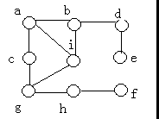
A. abcdefghi B. abcdeighf C. acbdieghf D.abdeighfc
6、In a binary tree, if the result of traversing under preorder is the same as that under inorder, then ( )
A. It is only a binary tree with one node
B. It is either empty, or the left subtree of any node of the tree is empty
C. It is only an empty binary tree
D. It is either empty, or the right subtree of an node of the tree is empty
7、There are _______solutions to the problem of placing four queens on a 4×4 board. ( )
A. 2 B. 3 C. 6 D. 4
8、Which function is smallest order of magnitude? ( )
A. 2 n B. n + lgn C.n 0.1 D.10000
9、The time requirement of retrieving a given target in hash table with n entries is ( )
A. O(n) B. O(log2n) C. O(1) D.O(nlog2n)
10、For the following binary tree, the result of traversing under postorder is ( )
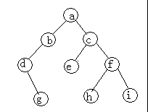
A. abcdefghi B. dgbechfia C. gdbaehifc D. gdbehifca
III、Analyze and Calculate ( 10′)
Let A be a upper triangular matrix and
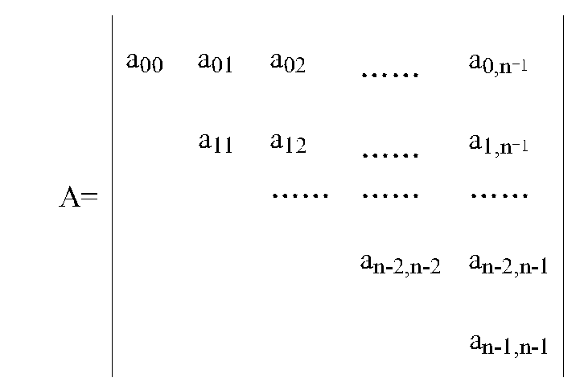
Suppose that
(a) Elements of A are stored in row-major ordering
(b) Each element occupies m memory locations
(c) Indexing begins at 0
Please give the calculating formula of loc(aij)(address of the element aij)
IV、Comprehensive Problem(7′×6=42′)
- Draw a diagram to illustrate the configuration of linked nodes that is created by the following statement.
Node *p0=new Node (a);
Node *p1=p0→next=new Node(b);
Node *p2=p1→next=new Node(c,p1);
2、Briefing the idea of Shellsort .
3、By hand, trace the action of heap_sort on the following lists. Draw the initial tree to which the list corresponds, show how it is converted into a heap, and show the resulting heap as each entry is removed from the top and the new entry inserted.
25 31 36 28 19 12 22
4、Suppose that
(a) A hash table contains hash_size=16 position indexed from 0 to 15
(b) A hash function H(key)=(key*3)%13
(c) The following keys are to be mapped into the table:
10 120 33 45 58 26 3 27 200 400 2
Draw the hash table with the collision resolution of linear probing.
5、Construct a minimal spanning tree of the following connected network..
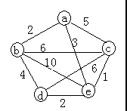
6、Given a sequence of keys:
A , Z, B,Y, C, X, D, W, E, V, F
Insert the keys in the order shown above, to build them into an AVL tree (draw the principal AVL tree).
V、Develop Algorithm(18′)
For linked implementation of binary trees, we have the following class specifications: template <class Entry>
struct Binary_node {
Entry data;
Binary_node <Entry>*left;
Binary_node <Entry>*right; };
template <class Entry>
class Binary_tree{
protected:
Binary_node<Entry>*root;
int recursive_height (Binary_node<Entry> *sub_root);
public:
int height(); //other function; };
template <class Entry>
int Binary_tree<Entry>::height() {
recursive_height(root);
}
Write the function recursive_height to compute the height of a binary tree.

Answer of Final Examination Paper On Data Structures (A)

I. 1、Recursion first function 2、stack reversing
3、modulus ( or % or mod) 4、O(n) O(1) (or constant) 5、binary search 6、O(n log2n) 7、directed with no cycle
II. 1、B 2、D 3、A 4、C 5、D 6、B 7、A 8、D 9、C 10、D
III.
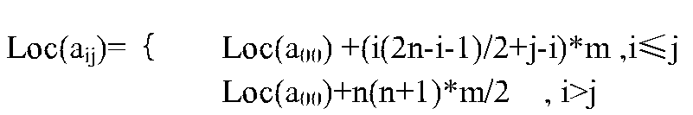
(不写不扣分)
IV. 1、
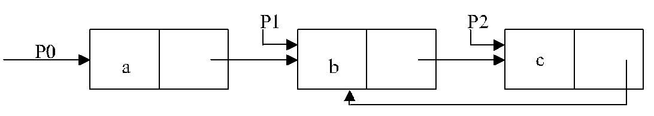
2、Repeat
(1) Choosethe increment di satsifies the followings
(a) d1<n, di+1 < di
(b) di is an integer
(2) Partition all entries into di groups (distance between entries is di)
(3) For each group,do straight insertion sort
While (di >1)、
3、
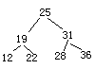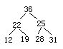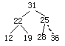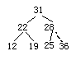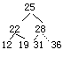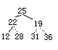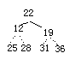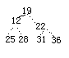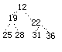
4、H（10）=2 H（120）=7 H（33）=6 H（45）=3 H（58）=3
H(26)=11 H(3)=7 H(27)=1 H(200)=0 H(400)=2 H(2)=4
(说明：以上计算结果可不写，直接给出下表即可)
0 | 1 | 2 | 3 | 4 | 5 | 6 | 7 | 8 | 9 | 10 | 11 | 12
200 | 27 | 10 | 45 | 58 | 400 | 33 | 120 | 3 | 2 |  | 26
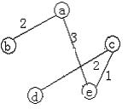
5、 6、
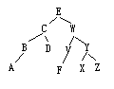
V．int Binary_tree<entry>::recursive_height(Binary_node<entry>*&sub_root)
{ int l,r,h; if(sub_root==NULL) return 0;
l=recursive_height(sub_root->left);
r=recursive_height(sub_root->right);
h=1+(l>r?l:r);
return h;
}

